State of Global Water Resources Report

- Quantitative status of groundwater -

|  |  |
| --- | --- |
| Title: | State of Global Water Resources Report  - Quantitative status of groundwater |
| Version: | Final #3 |
| Date: | 24th August 2023 |
|  |  |
| Authors: | Arnaud Sterckx, Elie Gergesand Elisabeth Lictevout |
|  |  |
| Lead organization | International Groundwater Resources Assessment Centre (IGRAC) |
| Address: | Westvest 7 2611AX Delft The Netherlands |
| Website: | [www.un-igrac.org](http://www.un-igrac.org) |
| Point of contact | Arnaud Sterckx, [armaud.sterckx@un-igrac.org](mailto:armaud.sterckx@un-igrac.org) |

# Introduction

Knowledge of the quantitative and qualitative status of aquifers is key for water resources planning and management, and for policy-making at all levels. Access to this information on a regular and timely basis is crucial because the stress on groundwater resources increases, due to the rise of water demand and the effect of climate change on water availability. Information on the quantitative and qualitative status of aquifers can be produced based on groundwater monitoring data and other physical evidences. It can be complemented with information about the recharge rate and the services provided by aquifers to the communities and the ecosystems. The dissemination of such information and the underlying data is a prerequisite for the active participation of communities and other stakeholders in the management of groundwater, which is itself a condition for effective groundwater management (FAO, 2016[1]).

Such monitoring and reporting strategies have been developed or are being developed in several parts of the world. Good examples can be found in Europe, under the Water Framework Directive, or in California, under the Sustainable Groundwater Management Act (SGMA). Under SDG indicator 6.3.2 (*Progress on ambient water quality*), countries report on the qualitative status of groundwater bodies, based on measurements of several groundwater quality variables. Unfortunately (and also quite surprisingly), there is no equivalent indicator to report on the quantitative status of groundwater bodies under the SDGs, even though many countries have developed quantitative groundwater monitoring networks (IGRAC, 2020[2]).

In this report, a methodology is proposed that builds upon these efforts in order to report on the state of groundwater resources at the global level. The methodology consists in reporting on the quantitative state of groundwater at the level of aquifers or other units that are relevant for the management of groundwater resources, based on in-situ groundwater level monitoring data.

# Methodology

## Outline

The quantitative status of groundwater in 2022 was assessed with two indicators that complement each other. The first indicator is the rank of the mean water level in 2022 in comparison with the mean annual water level in previous years. This allows qualifying the mean water level in 2022 as:

|  |  |
| --- | --- |
| “Above normal” | 0.75 < percentile |
| “Normal” | 0.25 < percentile < 0.75 |
| “Below normal” | percentile < 0.25 |

This indicator mirrors the other hydrologic variables covered by the State of Global Water Resources report. Since groundwater systems are usually less dynamic than surface water systems and have large water reserves, it is also relevant to assess the evolution of the water table over time. Therefore, a second indicator was calculated: the pluri-annual trend of mean water levels over the period of record. This allows determining whether the water table has been consistently declining, stable or rising.

Groundwater level ranking and trends are usually calculated over long-term time-series (> 30 years, usually). However, due to data availability constraints and for the sake of piloting, a single trend has been calculated here, over a period of 10 years ranging from 01/01/2013 until 31/12/2022.

Given the high number of reporting units and monitoring data at stake, a computer program has been developed to calculate the ranking and the trends (Annex I – Algorithm). It goes by the following steps:

1. Observation wells are grouped per reporting unit.
2. Groundwater levels monitored at each observation well are averaged into mean monthly values.
3. Time series with too many data gaps are discarded. Those are time series with less than 4 monthly values per year, on average, and more than 1 year without any data.
4. Monthly mean groundwater levels are normalized.
5. Monthly mean normalized groundwater levels are averaged over the reporting unit and fitted with a linear trend. The slope of this linear trend is categorized as declining, stable, or rising, according to the following rules:

|  |  |
| --- | --- |
| *Rising:* | *slope > 0.1 m/yr.* |
| *Stable:* | *-0.1 m/yr. < slope < 0.1 m/yr.* |
| *Declining:* | *slope < -0.1 m/yr.* |

1. Monthly mean normalized groundwater levels are further averaged per year, in order to rank the mean yearly value of 2022 in comparison with mean yearly values of the previous years.

In addition, the size of each reporting unit is divided by the number of observation wells, to give an idea of the representativity of the monitoring data. There is no gold standard to evaluate the representativity of observation wells, as it is highly dependent on the physical context and the location of the wells, yet a higher number of observation wells will usually inspire a greater confidence in the final results.

This methodology is fairly simple. It allows everyone to grasp what the results (the ranking and the trends) represent and how they were calculated. The number of observation wells that have been used for each reporting unit gives an indication of the reliability of the results. This does not only contribute to transparency, it also indicates where monitoring networks should be reinforced with additional observation wells.

NB: These two indicators are quantitative, not qualitative, i.e. they are not enough to determine whether groundwater is in a good state or a bad state, as it depends on context-specific factors. For instance, a water level decrease of 1 m might be acceptable in many aquifers, but it could have harmful consequences in other aquifers on which groundwater-dependent ecosystems or shallow wells rely. In some places, a rise of water levels can even be considered as negative, like for instance in shallow aquifers in urban areas. Determining whether an groundwater is in a good or bad quantitative state will therefore require additional information and local expertise. There would be a scope to collect and compile such information, where available, in complement to the quantitative analysis provided here.

## Case-studies and data collection

This report is the first edition to contain information about groundwater. Therefore, the methodology has been applied (“piloted”) to a selection of case-studies, i.e. countries where maps of aquifers or other relevant reporting units (in geospatial vector format) and groundwater level monitoring data are readily available. Case-studies have also been selected in order to cover all continents (excepted Antarctica). The datasets used in each case-study are presented in this section.

### Australia

Groundwater monitoring data were downloaded from the Australian Groundwater Explorer[3], which contains groundwater information submitted by the States and Territories. Some 2.000 boreholes are monitored on a regular basis. At the time of the download, monitoring data were available until April 2022.

Several units are available to calculate average water level trends: upper, middle, and lower aquifers, aquifer provinces, hydrogeological units and hydrogeological complexes. There are also groundwater management areas, which are not only based on the hydrogeology but also on socio-economic variables, for the purpose of groundwater management. The shapefiles of these maps can also be downloaded in the Australian Groundwater Explorer. Borehole datasets associate boreholes with hydrogeological units and hydrogeological complexes (according to the National Aquifer Framework (NAF) or to hydrogeological classifications in the States and Territories), as well as aquifer provinces. However, this information is missing for several boreholes, while several units reported in the borehole datasets are not contained in the maps’ shapefiles. Since several aquifers overlap each other, it was not an option to associate observation wells with reporting units based on their location. Due to these constraints, the hydrogeological complexes as defined by the NAF were used as reporting units, although they are very large units.

### Brazil

The Geological Survey of Brazil (*Serviço Geológico do Brasil, SGB*) operates a national groundwater monitoring network (*Rede Integrada de Monitoramento das Águas Subterrâneas*, RIMAS) of over 400 wells[4]. The data can be downloaded online on the website of the national groundwater monitoring network[5]. They are also available in the Global groundwater Monitoring Network (GGMN)[6].

The hydrogeological map of Brazil at the scale 1:1.000.000[7] published by SGB in 2014 was used as reference map. The map shows the extent of stratigraphic units (those outcropping and the underlying ones). The monitoring database indicates to which stratigraphic unit each well belongs.

### Canada

The Groundwater Information Network (GIN) gives access to a compilation of groundwater monitoring data collected by the provinces and territories of Canada[8]. However, the dataset has not been updated over the last few years, so it has been complemented with recent data shared by the Department of Natural Resources of Canada (NRCan). Nevertheless, recent data from some provinces (e.g. Quebec) are missing out.

Average water level trends were calculated over the *key Canadian aquifers*, as defined by the Groundwater Mapping Program of the Geological Survey of Canada. The map of these aquifers in geospatial vector format is also available in the GIN. Monitoring stations were associated with the key Canadian aquifers based on their location. The key Canadian aquifers cover only a small part of the country. Therefore, several monitoring data falling outside of the key Canadian aquifers have not been included in the analysis. It would have been possible to perform the analysis over the hydrogeological regions of Canada, which have the advantage to cover the entire country, yet there are only 9 hydrogeological regions and it did not seem meaningful to calculate the two indicators over such large areas.

### Chile

Groundwater monitoring data were requested and obtained from the General Water Directorate (*Dirección General de Aguas*). Data can also be downloaded from the website of the Directorate[9] per monitoring well.

Average water level trends were calculated over the 86 aquifers identified under the national inventory of aquifers of 2023 (*Inventario Nacional de Acuíferos*), which is available online[10]. Observation wells have been associated with aquifers based on their location.

### Czech Republic

A selection of reliable and long-term groundwater monitoring data from 59 observation wells is made available by the Czech Hydrometeorological Institute (*Český hydrometeorologický ústav*) in the GGMN, whereas the map of groundwater bodies (the groundwater reporting unit used under the European Water Framework Directive) have been downloaded from the online map application of the Czech Hydrometeorological Institute[11]. The application also indicates to which groundwater body each monitoring station is associated[12].

### France

Groundwater monitoring data from France can be downloaded online from the ADES platform[13]. For the sake of this study, a subset of highly reliable data shared by the French Geological Survey (*Bureau de Recherches Géologiques et Minières*, BRGM) has been used. It contains data from about 600 observation wells.

As for Czech Republic, the analysis was done at the groundwater body level. Over 600 groundwater bodies have been identified in France under the latest WFD reporting phase. A delineation of aquifers is also available in France (*Base de Données des Limites des Systèmes Aquifères*, BDLiSA) and is available online[14]. It has a higher number of entities than the groundwater bodies, however the delineations of the two units coincide. The monitoring dataset indicates to which groundwater body (and which aquifer) each monitoring station is associated.

### South Africa

The Department of Water and Sanitation (DWS) of South Africa operates a National Groundwater Archive[15], where groundwater monitoring data can be downloaded or requested (in case of large datasets). The country-wide dataset contains monitoring data from some 1.800 observation wells.

Average water level trends have been calculated over the groundwater regions defined by Vegter (2001)[16]. There are 64 groundwater regions, which have been delineated according to various criteria, including the lithology, recharge rates and regional hydraulic gradients. The map has been shared in geospatial vector format by the Water Research Commission. The groundwater regions are quite heterogeneous, they have not been further delineated into aquifers or aquifer systems.

The monitoring dataset indicates in which hydrogeological region each monitoring station is located. However, it does not report how many aquifers each borehole intersects. It the future, it would be possible to focus the analysis on the Strategic Water Source Areas of South Africa[17].

### South Korea

Groundwater monitoring data were shared by the National Groundwater Information Center of South Korea[18]. Data can also be downloaded or requested (for large data sets) from the Groundwater Big Data Platform per monitoring well. The dataset contains about 700 monitoring wells.

A detailed hydrogeological map is available in South Korea but there is no delineation of aquifers or aquifer systems, possibly because the geology of South Korea is dominated by crystalline rocks. Average water level trends have been calculated over river sub-basins units, which are used for surface water reporting. There are 21 river basins in South Korea, divided into 117 sub-basins. The monitoring dataset indicates in which river basin each monitoring station is located.

### Thailand

Groundwater monitoring data were downloaded from the data platform operated by the Department of Groundwater Resources[19]. Data from over 3.000 observation wells were downloaded.

The country is divided in 27 groundwater basins, over which average water level trends have been calculated. Monitoring stations were associated to groundwater basins based on their location.

### USA

Groundwater monitoring data were downloaded from the National Ground-Water Monitoring Network[20], which compiles groundwater monitoring data collected by federal, state, and local monitoring programs over the USA.

Average water level trends were calculated over the principal aquifers of the United States, which are defined as regional aquifers or aquifer systems with the potential to be used as a source of potable water. The map layer showing the areal extent of the uppermost principal aquifers on a national scale was downloaded[21]. It contains the contours of 64 principal aquifers. No calculation was made over the areas covered by “Other rocks”, because they are spread over the entire country. The monitoring data downloaded from the National Ground-Water Monitoring Network mention which principal aquifer each observation well taps.

# Results

This section contains the maps of the two indicators (groundwater level rank and groundwater level trend), for each case-study. The hydrographs that have been calculated for each reporting unit are provided in Annex II – Hydrographs.

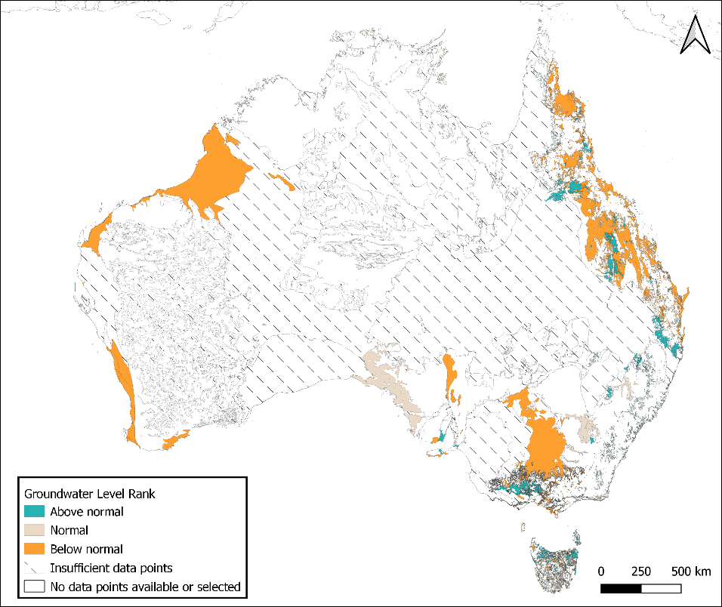

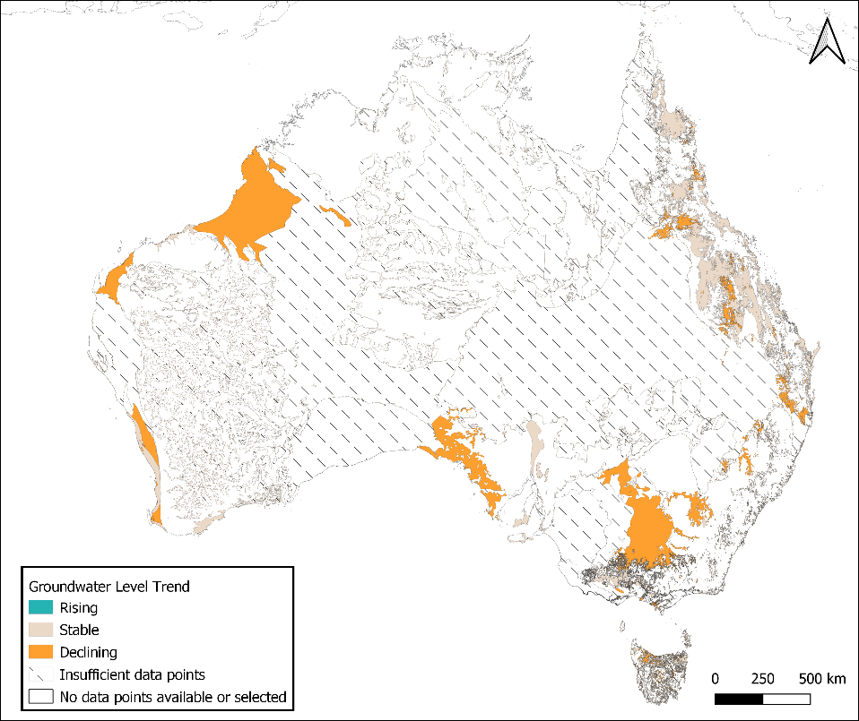

Figure 1 Groundwater level rank and trend in Australia.

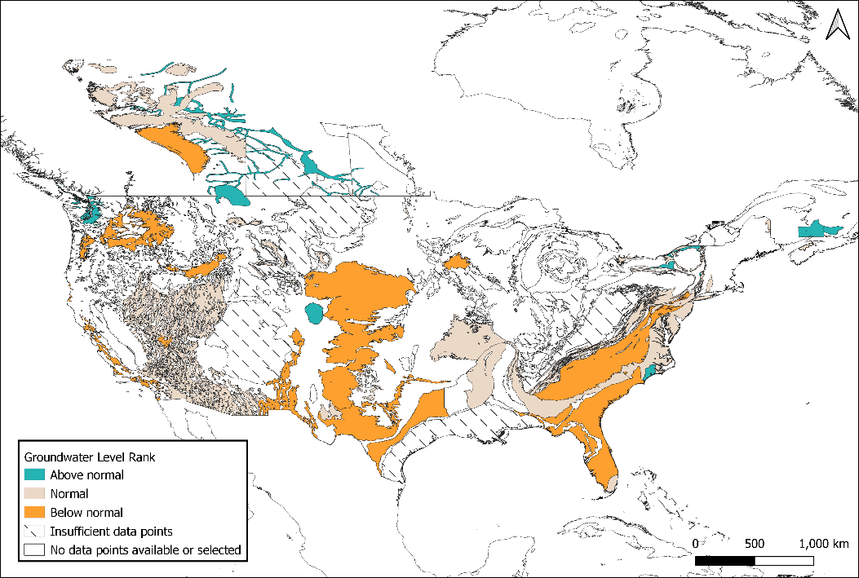

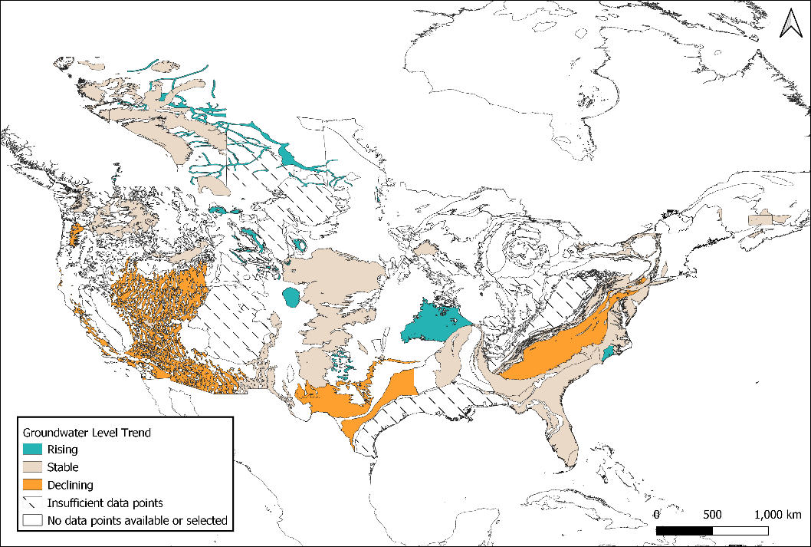

Figure 2 Groundwater level rank and trend in Canada and USA.

|  |  |
| --- | --- |
|  |  |

Figure 3 Groundwater level rank and trend in Brazil and Chile.

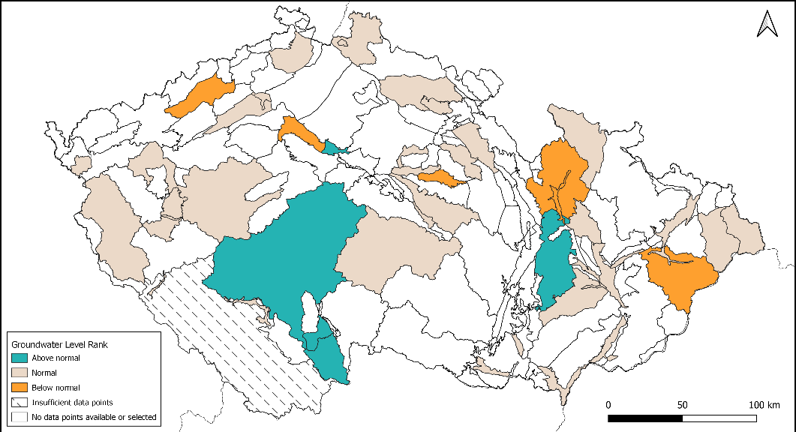

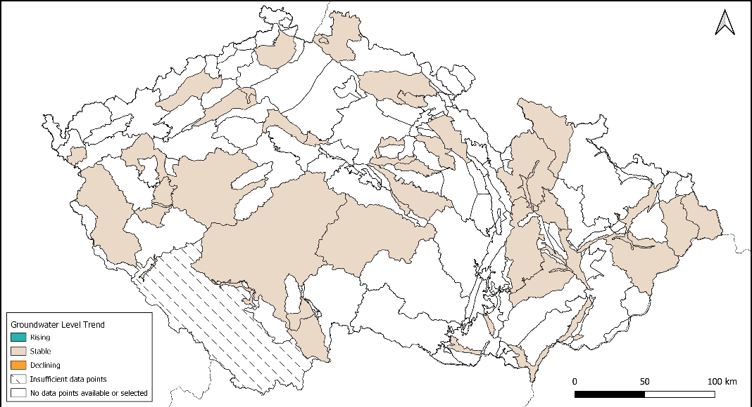

Figure 4 Groundwater level rank and trend in Czech Republic.

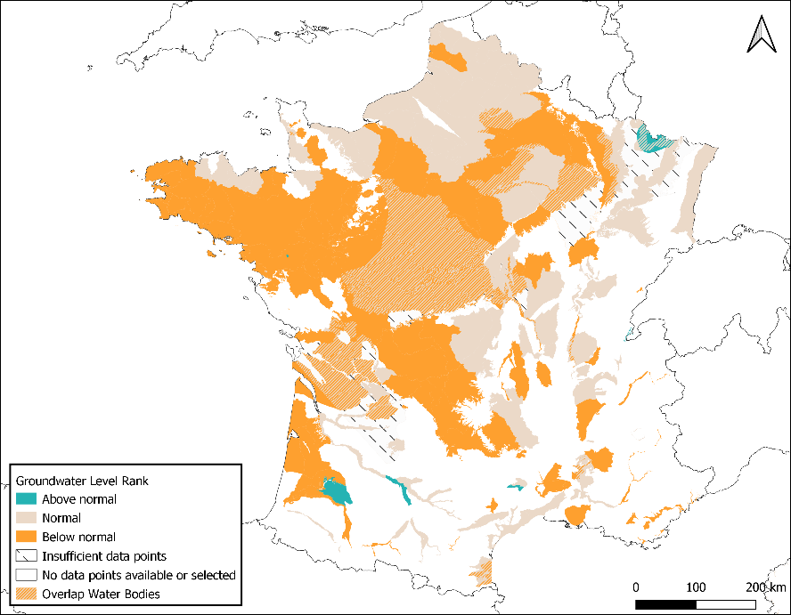

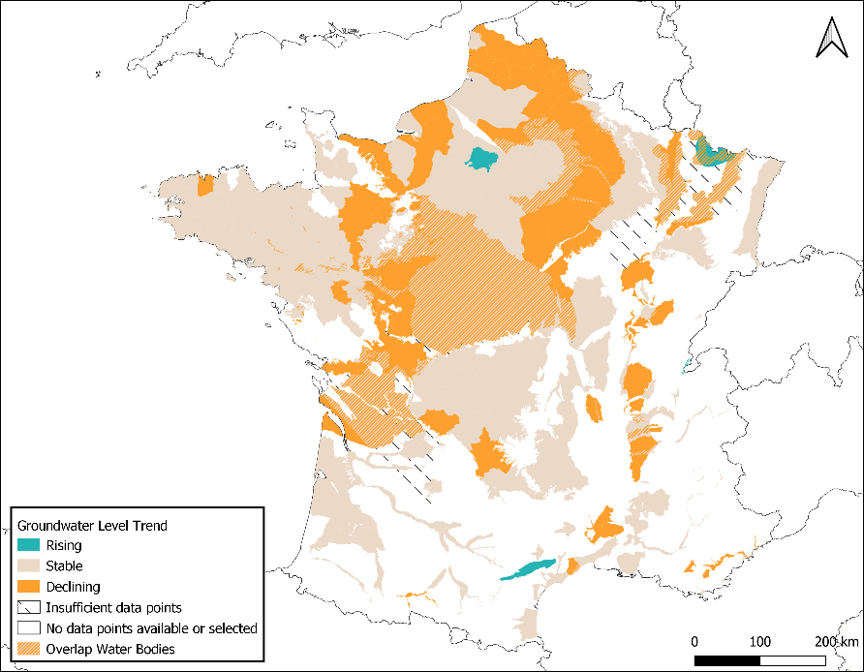

Figure 5 Groundwater level rank and trend in France.

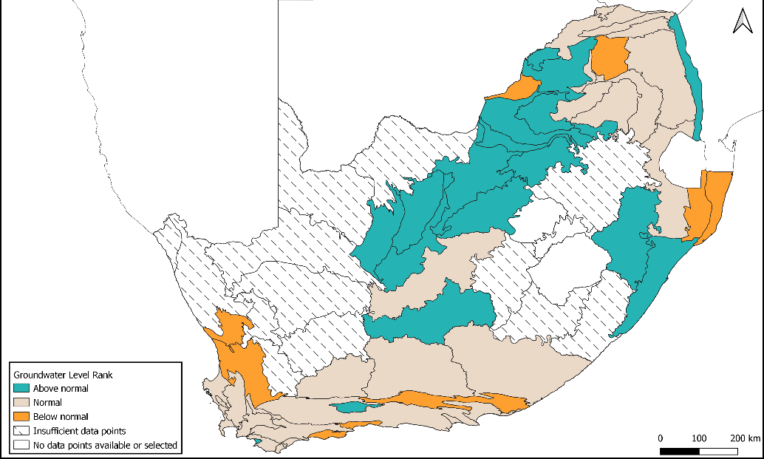

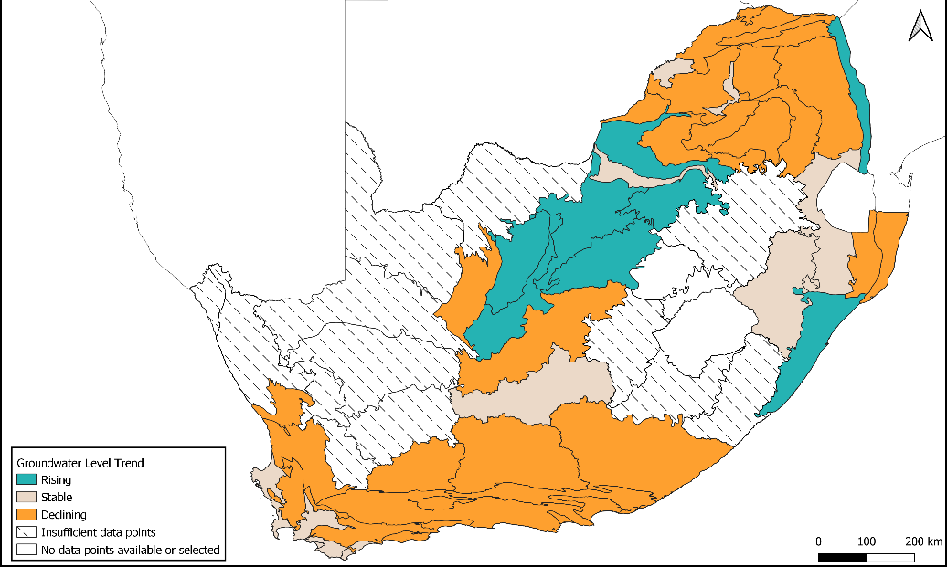

Figure 6 Groundwater level rank and trend in South Africa.

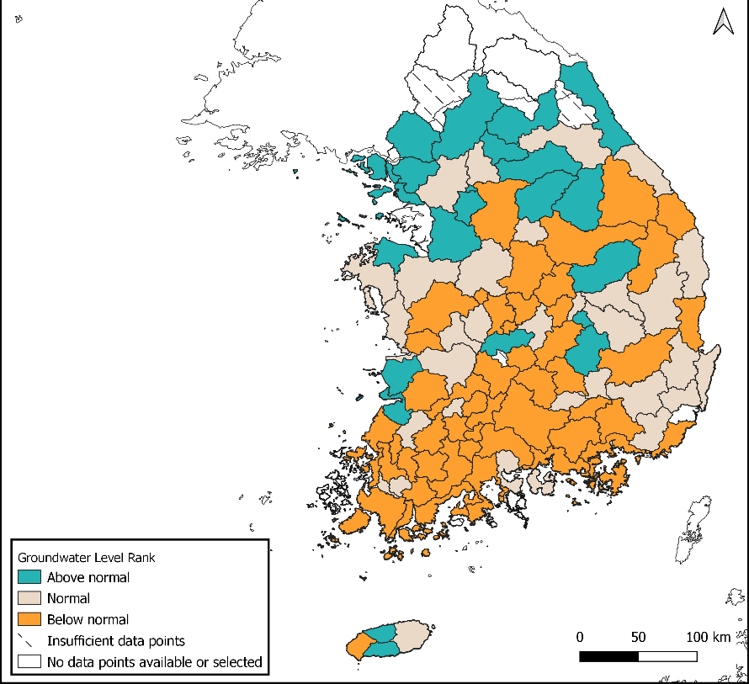

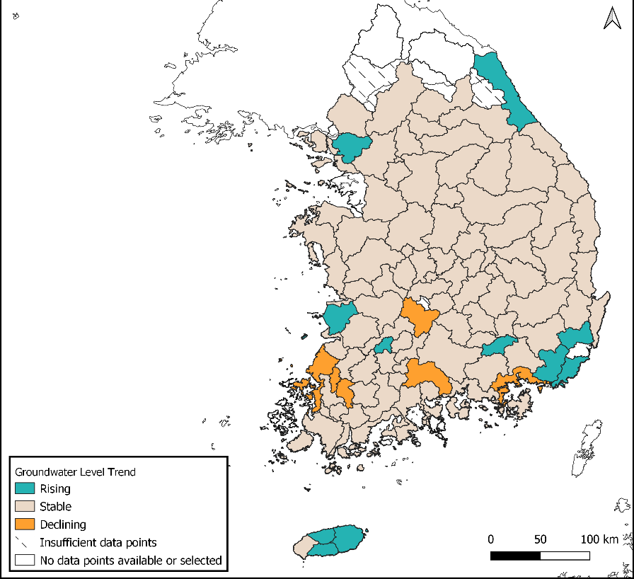

Figure 7 Groundwater level rank and trend in South Korea.

|  |  |
| --- | --- |
|  |  |

Figure 8 Groundwater level rank and trend in Thailand.

# Analysis

The objective of this first-time analysis was not to provide formal statements on the state of groundwater, but rather to demonstrate the potential of such reporting methodology to assess groundwater resources at the global level. For the sake of interpretation, additional information on climatic variables, abstraction and further characterization of the aquifers and other reporting units could be used. There are also some limitations that need to be overcome.

## Suspicious data

Some time series exhibit suspicious data. Suspicious data were not found to have a significant impact on the mean values that were calculated. Nevertheless, it would be possible in subsequent editions to apply logical rules to filter some of the most obvious outliers, whereas expert knowledge might help filtering erroneous data that are less straightforward. It would be helpful if the responsible organizations could indicate which data are appropriate for the analysis, like Czech Republic and France have done.

## Density of monitoring stations

Assessing the state of aquifers or other reporting units requires sufficient (sufficiently representative) monitoring wells. Whether the monitoring network is sufficient to accurately describe the aquifer depends on the amount of monitoring wells, their location, and the complexity of the aquifer. Monitoring networks are usually designed to be representative at the cost of a limited number of monitoring stations. In this study, the size of the aquifer was divided by the number of monitoring wells, as an indicator of the representativeness (and thus the reliability) of the results. For the sake of visualization, reporting units with little monitoring stations were mapped with a hashed pattern, and the threshold was (quite arbitrarily) set on 1 monitoring well / 5.000 km2. This threshold is rather low, and more monitoring stations will be needed where the dependency of communities and ecosystems on groundwater is high.

## Heterogeneous reporting units

Reporting at the level of aquifers or other similar reporting units assumes that groundwater behaves (relatively) homogeneously within the reporting unit. As a rule of thumb, the larger the unit, the more heterogeneities can be observed. As an example, calculations show that the trend of water levels in the High Plains aquifer in the United States has been stable over the last 10 years. This is a surprising outcome given that the aquifer has been knowingly depleted for several decades. Yet, a closer look shows that depletion mostly happens over the states of Texas and Kansas[22]. The calculations only reflect this trend when further dividing the aquifer into state-segments, in which case it shows for example a general decline of the water table of more than 2 meters in Texas over the last 10 years (Figure 2).

Figure 2 10-years trend of water levels in the entire High Plains aquifer (first chart) and in the Texas-segment of the High Plains aquifer (second chart). Light grey lines represent the time series of the observation wells, the black line represents the mean and the dotted line represents the linear trend.

## Short period of records

For the sake of piloting, 10-years’ time series have been analysed. In some (usually large and deep) aquifers, this is not enough to capture water level dynamics taking place on the long-term, such as pluri-annual cyclic variations or delayed responses to changes in recharge or discharge mechanisms and rates. This issue will be overcome in the next editions by using longer time-series wherever available.

## Methodological choices

Several European countries use Mann-Kendall tests instead of linear regressions to evaluate whether water levels are declining (or rising). This test has the advantage to identify a decline only if it is consistent and statistically significant. This test might be more appropriate than the linear regression in reporting units where water level trends are not linear. In addition, some countries perform the test over each time-series before aggregating them over the reporting units. These methodological choices might have an impact on the final outcomes. A sensitivity analysis will be carried out in order to consolidate the methodology before the next edition of the report.

# Main challenges and recommendations

In addition to these limitations, the study came with a few challenges. When possible, recommendations are made to overcome these challenges in the next edition of the report.

## Availability of recent monitoring data

It often takes a certain period of time (several months on average) between the collection of data and the sharing of data. This time is usually required for compiling the data, for quality checks and for recording the data in the database. For instance, data have been collected from Spain[23] and India[24], but the time series unfortunately stop in 2020. Data from Australia were used, even though they stop in April 2022. In Canada and USA, 2022’ data from some states and provinces were not yet available. Because of that, reporting on the elapsed year within a couple of months might be challenging.

## Data processing and formatting

A large amount of time was necessary to collect and to prepare the data in the right format for the analysis. In subsequent editions, it is suggested that countries share their data in a predefined format. Sharing the data in a global platform like the Global Groundwater Monitoring Network would considerably speed up the entire process, in the sense that data would be readily available and in a harmonized format[25].

## Reporting units

A variety of reporting units have been used in this study (Table 1). This is not a problem, as long as the countries find these units relevant for the sake of groundwater reporting and management. What is of importance is that groundwater behaves (relatively) homogeneously within these units, otherwise averaging the water levels will not be meaningful.

Table 1 Reporting units used in this study.

|  |  |  |
| --- | --- | --- |
| # | Country | Reporting unit |
|  | Australia | Hydrogeological units (NAF) |
|  | Brazil | Stratigraphic units |
|  | Canada | Key Canadian aquifers |
|  | Chile | Aquifers |
|  | Czech Republic | Groundwater bodies |
|  | France | Groundwater bodies |
|  | South Africa | Groundwater regions |
|  | South Korea | River basins |
|  | Thailand | Groundwater basins |
|  | USA | Principal aquifers |

In subsequent editions of the report, it is recommended to identify the reporting units jointly with national experts. As experience with groundwater bodies’ delineation has shown in EU, this could become an iterative process, in which reporting units can be refined according to the latest knowledge available on groundwater resources.

## Time-series analysis

Ranking and trends have been calculated over 10-years’ time-series in order to ensure the availability of time series in the selected case studies. In subsequent editions, longer time-series will be used where available. Moreover, it would be possible to also consider shorter trends (< 5 years, for example), to capture the recent evolution of groundwater. For instance, the stabilization or the recovery of water levels that could follow a phase of groundwater development, or the depletion of aquifers caused by recent dry years. It would also be possible to capture the intra-annual variation of water levels, to identify which aquifers are prone to seasonal drought. There is quite a range of possibilities that could be explored. The insight of country experts on this issue would be most useful.

## Visualization

Since only a few case-studies have been considered in this pilot study, results were not presented on a global map, but on national/regional maps. The maps show whether water levels have been declining, stable or rising over the last 10 years, whereas hashed patterns indicate the density of wells that have been considered in each reporting unit (as an indicator of the reliability of the results). Displaying the results on a map was challenging wherever reporting units overlap each other, as in France for example. There, symbology colours were combined to represent areas where units with different trends overlap. This solution might however not be applicable wherever the densities of wells differ.

In the next edition, the objective is to achieve a global coverage and to display the results on a global map. Small reporting units will not be visible on a global map, therefore it will be necessary to aggregate the results, for instance over river basins or grid cells. Results could also be aggregated at the country level, in which case they would nicely complement SDG Indicator 6.5.2 showing the proportion of groundwater bodies with good ambient water quality. The global map could be complemented with regional maps to zoom in on hotspots areas. For more information on a specific aquifer or country, the readers could always look back at the aquifer charts, as presented in Annex II – Hydrographs.

# Acknowledgements

The authors are grateful to the organizations that have made their groundwater data available, either upon request or through online platforms:

|  |
| --- |
| * Bureau of Meteorology (BOM), Australia |
| * Geological Survey of Brazil (SGB) |
| * Department of Natural Resources of Canada (NRCan) |
| * General Water Directorate (DGA), Chile |
| * Czech Hydrometeorological Institute |
| * Geological Survey of France (BRGM) |
| * Department of Water and Sanitation (DWS), South Africa |
| * Water Research Commission (WRC), South Africa |
| * Groundwater Information Management and Service Center (GIMS), South Korea |
| * Department of Groundwater Resources (DGR), Thailand |
| * United States Geological Survey (USGS) |

The authors are also grateful to Claire Michailovsky, from IHE-Delft, for her kind assistance in writing the algorithm.

# Annex I – Algorithm

*See attached file.*

# Annex II – Hydrographs

*See attached file.*

1. FAO (2016) Global Diagnostic on Groundwater Governance. FAO, Rome. Available from: http://www.fao.org/3/a-i5706e.pdf
2. IGRAC (2020) Groundwater monitoring programmes: A global overview of quantitative groundwater monitoring networks. Available from: https://www.un-igrac.org/resource/national-groundwater-monitoring-programmes-global-overview-quantitative-groundwater
3. http://www.bom.gov.au/water/groundwater/explorer/map.shtml
4. http://rimasweb.sgb.gov.br/layout/index.php
5. http://rimasweb.sgb.gov.br/layout/pesquisa_complexa.php?rimas=true
6. https://ggis.un-igrac.org/view/ggmn/
7. https://rigeo.sgb.gov.br/handle/doc/15556
8. https://gin.gw-info.net/service/api_ngwds:gin2/en/gin.html
9. https://snia.mop.gob.cl/BNAConsultas/reportes
10. https://dga.mop.gob.cl/estudiospublicaciones/mapoteca/Paginas/Mapoteca-Digital.aspx
11. https://chmi.maps.arcgis.com/apps/webappviewer/index.html?id=e6b21710086c43008b63bc857357ac2c
12. https://chmi.maps.arcgis.com/apps/webappviewer/index.html?id=ccb8ecca6e5c4c87abd57d071519d8f8
13. https://ades.eaufrance.fr/Recherche
14. https://bdlisa.eaufrance.fr/
15. https://www.dws.gov.za/NGANet/Security/WebLoginForm.aspx
16. Vegter, J.R. 2001. Groundwater Development in South Africa and an Introduction to the Hydrogeology of Groundwater Regions. Water Research Commission. WRC Report No. TT 134/00
17. https://www.csir.co.za/strategic-water-source-areas-south-africa
18. https://www.gims.go.kr/en/gims_start.do
19. http://tgms.dgr.go.th/#/home
20. https://cida.usgs.gov/ngwmn/index.jsp
21. https://www.usgs.gov/mission-areas/water-resources/science/principal-aquifers-united-states
22. https://www.usgs.gov/news/technical-announcement/usgs-high-plains-aquifer-groundwater-levels-continue-decline
23. https://www.miteco.gob.es/es/cartografia-y-sig/ide/descargas/agua/red-seguimiento-estado-cuantitativo.aspx
24. https://indiawris.gov.in/wris/#/DataDownload
25. The GGMN already contains the data from several countries, however the most recent data were often missing. Automatic connections between the GGMN and the country servers seems the way forward. Otherwise, increased efforts will be needed to update the data manually.